**Title of the Project**

A Project Report submitted in partial fulfillment of the requirements for the award of the degree of

**Bachelor of Technology**

### in

**Computer Science and Engineering/ Electronics and Communication Engineering**

by

### Student’s Name/ Group Members’ Names (with MIS Number in Brackets):

**Under the Supervision of: Supervisor’s Name**

### Semester:



#### Name of Department: Department of Computer Science and Engineering/ Department of Electronics and Communication Engineering

#### 

#### Indian Institute of Information Technology, Pune

**(An Institute of National Importance by an Act of Parliament)**

#### November 2023

**BONAFIDE CERTIFICATE**

This is to certify that the project report entitled **“Title of the Project”** submitted by **Students’ Name** bearing the **MIS No: ____**, **Students’ Name** bearing the **MIS No: _____**, **Students’ Name** bearing the **MIS No: ____**, in completion of his/her project work under the guidance of **Supervisor’s Name** is accepted for the project report submission in partial fulfillment of the requirements for the award of the degree of **Bachelor/Master of Technology** in the **Department of Computer Science and Engineering/ Electronics and Communication Engineering**, Indian Institute of Information Technology, Pune (IIIT Pune), during the academic year **2022-23**.

#### Supervisor’s Name HoD Name

Project Guide Head of the Department

Designation of the Supervisor Assistant Professor

Department of the Supervisor Department of CSE/ECE

IIIT Pune IIIT Pune

Project Viva-voce held on

**Undertaking for Plagiarism**

I/We **Students’ Names** solemnly declare that research work presented in the **report/dissertation** titled **“…………………………………………..………………………………………………………… ……………………………………………………………………………….…………………….”** is solely **my/our** research work with no significant contribution from any other person. Small contribution/help wherever taken has been duly acknowledged and that complete report/dissertation has been written by **us/me**. I understand the zero tolerance policy of **Indian Institute of Information Technology Pune** towards plagiarism. Therefore **I/we** declare that no portion of my **report/dissertation** has been plagiarized and any material used as reference is properly referred/cited. I undertake that if I am found guilty of any formal plagiarism in the above titled thesis even after award of the degree, the Institute reserves the rights to withdraw/revoke my **B.Tech/M.Tech** degree.

**Students’/ Student’s Name and Signature with Date**

**Conflict of Interest**

**Manuscript title: ________________________________________________________________**

The authors whose names are listed immediately below certify that they have NO affiliations with or involvement in any organization or entity with any financial interest (such as honoraria; educational grants; participation in speakers’ bureaus; membership, employment, consultancies, stock ownership, or other equity interest; and expert testimony or patent-licensing arrangements), or non-financial interest (such as personal or professional relationships, affiliations, knowledge or beliefs) in the subject matter or materials discussed in this manuscript.

**Students’/ Student’s Name and Signature with Date**

## ACKNOWLEDGEMENT

This project would not have been possible without the help and cooperation of many. I would like to thank the people who helped me directly and indirectly in the completion of this project work.

First and foremost, I would like to express my gratitude to our honorable Director, **Prof. O.G. Kakde**, for providing his kind support in various aspects. I would like to express my gratitude to my project guide **Supervisor’s Name**, **Department of CSE/ECE**, for providing excellent guidance, encouragement, inspiration, constant and timely support throughout this **M.Tech/B.Tech Project**. I would like to express my gratitude to the **Head of Department (Name)**, **Department of CSE**, for providing his kind support in various aspects. I would also like to thank all the faculty members in the **Department of CSE/ECE** and my classmates for their steadfast and strong support and engagement with this project.

**(Note: Students may add or change the Acknowledgement as per their preference, but it must not exceed one page.)**

Title

## Abstract

**Keywords:** Covid detection, Artificial Intelligence, Deep Learning

## TABLE OF CONTENTS

**Abstract i**

**(i)** **List of Figures/Symbols/Nomenclature iv**

**(ii)** **List of Tables v**

1. **Introduction 1**

1.1 Overview of work . . . . . . . . . . . . . . . . . . . . . . . . . . . . . . . . . . 1

1.2 Motivation of work . . . . . . . . . . . . . . . . . . . . . . . . . . . . . . . . . 1

1.3 Literature Review . . . . . . . . . . . . . . . . . . . . . . . . . . . . . . . . . . 1

1.4 Research Gap. . . . . . . . . . . . . . . . . . . . . . . . . . . . . . . . . . . . . 1

1. **Problem Statement**

2.1 Research Objectives . . . . . . . . . . . . . . . . . . . . . . . . . . . . . . . . . 1

2.2 Methodology of work . . . . . . . . . . . . . . . . . . . . . . . . . . . . . . . . . 1

1. **Analysis And Design 5**
2. **Results and Discussion 9**
3. **Conclusion and Future Scope 10**

**6 References**

**7 Publication (if any)**

# List of Figures / Symbols/ Nomenclature

# List of Table

**Introduction**

**Dementia and its types:**

Dementia is a degenerative neurological disorder that affects a person's cognitive and behavioural functioning, including their memory, language, reasoning, and social skills. It is a serious and progressive condition that can profoundly impact a person's quality of life, as well as that of their loved ones. Unfortunately, there is no cure for Dementia.

Dementia is a collective term encompassing various cognitive disorders, each with its distinct characteristics:

1. Alzheimer's Disease (AD): AD is the most common form of dementia, characterized by the accumulation of amyloid beta in the brain, leading to progressive cognitive decline. Memory loss, disorientation, and impaired problem-solving are common symptoms.

2. Vascular Dementia (VaD): VaD results from reduced blood flow to the brain, often due to minor strokes or other vascular problems. Cognitive abilities decline gradually, and symptoms can vary depending on the affected brain regions.

3. Lewy Body Dementia (LBD): LBD is identified by abnormal alpha-synuclein protein deposits in the brain. It affects thinking, behavior, and movement, often causing visual hallucinations, motor difficulties, and mood swings.

4. Frontotemporal Dementia (FTD): FTD involves the loss of nerve cells in the frontal and temporal brain regions, leading to changes in behavior, language, and motor skills. This type is more common among younger individuals.

5. Mixed Dementia (MD): MD occurs when a person experiences more than one type of dementia simultaneously, often a combination of Alzheimer's and Vascular Dementia. It can be challenging to diagnose and manage due to its complex nature.

**How does it impact People?**

As dementia worsens, people may find it harder to do simple tasks like dressing, cooking, and managing their finances. Additionally, they could become disoriented, confused, and forgetful, which can result in injury, sadness, and even social isolation.

Dementia can have a significant influence not only on the person who is suffering from it but also on their relatives and carers. It can be emotionally and physically taxing to deal with the problems of caring for a loved one who has dementia, so it's important to look for help and resources to make sure that both the patient's needs and the needs of their caregivers are fulfilled.

The number of people living with dementia worldwide is expected to increase by upward of 40 percent over the next several years, according to new data from the World Health Organization (WHO). The number of dementia patients is projected to rise to 78 million globally by 2030 and to 139 million by 2050, citing a newly released analysis from WHO.  Currently, more than 55 million people suffer from the degenerative neurological disease, WHO noted, an epidemic that the organization estimated costs $1.3 trillion a year on a global scale.

[Number of people with dementia set to jump 40% to 78 mLn by 2030 -WHO | Reuters](https://www.reuters.com/business/healthcare-pharmaceuticals/number-people-with-dementia-set-jump-40-78-mln-by-2030-who-2021-09-02/)]

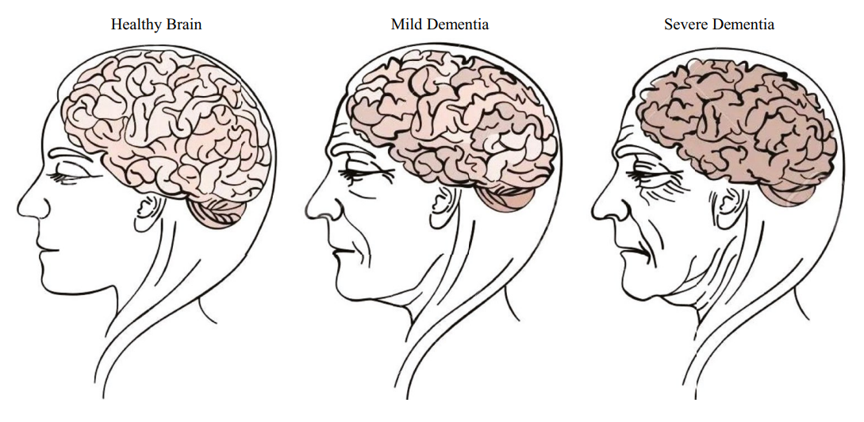

**Detecting Dementia**

There is no single test that can diagnose dementia. A number of medical tests and your medical history are used to make the diagnosis. Following are some common tests that are used by medical practitioners for the screening of dementia.

1. Mini-Mental State Examination (MMSE): The Mini-Mental State Examination (MMSE) is a quick test that evaluates cognitive function, including orientation, memory, attention, language, and visuospatial abilities. It is frequently employed to test for cognitive impairment and track changes over time.

2. Montreal Cognitive Assessment (MoCA): The MoCA is a more sensitive test than the MMSE and assesses a broader range of cognitive domains, including attention, memory, language, and visuospatial skills. It takes about 10-15 minutes to administer and is considered a more accurate tool for detecting early signs of cognitive impairment.

3. Clock Drawing Test: The Clock Drawing Test is a simple screening tool that assesses a person's ability to follow verbal instructions, spatial awareness, and executive function. It involves asking the person to draw a clock face and set the time to a specific hour.

It is crucial to understand that none of them are diagnostic tests; rather, they are merely instruments used by medical practitioners to support clinical analysis. To determine if a patient has dementia or not, a professional must perform additional testing.

Therefore, since there is no established diagnosis, a professional is required to carefully evaluate the patient and make a determination. On top of that, we have a major shortage of reliable experts in our field. This emphasizes a significant difficulty that the medical community is currently facing and the reason why we want technology assistance.

## 

## Motivation of the Work

Dementia is a heart-wrenching condition that doesn't just affect individuals; it casts a long, daunting shadow over their families, loved ones, and the healthcare professionals caring for them. Witnessing a dear one lose their sense of self and become increasingly helpless is emotionally draining. The current diagnostic tests for dementia often fall short, as they struggle to predict the onset of this condition on a smaller timescale and frequently result in misdiagnosis. These inaccuracies put immense mental strain on the patient's family, compounding the already challenging situation.

Furthermore, in low-income countries, the scarcity of resources compounds this issue, denying proper healthcare access to a large portion of the population soon to face the brunt of dementia cases worldwide. This looming crisis demands a solution that can revolutionize the early detection of dementia. This is where Machine Learning steps in.

Machine Learning has the potential to aid healthcare workers in detecting dementia at an early stage. Not only can it extend the patient's dignified livelihood, but it can also reduce the rate of misdiagnoses and provide medical practitioners with a more reliable and error-resistant tool for assessing clinical data. In a world where a cure for dementia remains elusive, early detection becomes paramount. In some exceptional cases, dementia can be reversed, and in others, it can provide a longer, cognitively functional life to our elders. It's crucial to understand that dementia is not a normal part of aging. While it has a higher likelihood of affecting individuals over 65, it is by no means a natural part of the aging process. Studies linking dementia to environmental factors, like pollution, have shed light on why our generation may face a surge in dementia cases.

The numbers and probabilities are staggering, guaranteeing that each of us will likely witness someone we care about suffering from dementia. Therefore, addressing this critical challenge in dementia care is vital. A shortage of specialists capable of accurate diagnosis impedes timely interventions, making it even more important to embrace the power of Machine Learning. By applying ML algorithms to diverse datasets, we can enhance the diagnostic process, ensuring that individuals, no matter where they are, have access to accurate and timely diagnosis.

Moreover, the exorbitant costs associated with dementia tests create insurmountable barriers for many individuals and families, preventing them from obtaining timely diagnosis and support. Our project seeks to eliminate this financial hurdle by developing cost-effective ML-powered solutions. We aim to democratize access to diagnostic tools, making them affordable and accessible to all. Through this, we hope to break down the financial barriers that prevent early diagnosis due to economic constraints, ensuring that no one is deprived of the opportunity for timely intervention.

**Literature Review**

**“Early Diagnosis of Dementia from Clinical Data by Machine Learning Techniques”**

*By So A, Hooshyar D, Lim HS Department of Computer Science and Engineering, Korea University, Seoul 100-744, Korea and Park KW from Department of Neurology, College of Medicine, Korea University, Seoul 100-744, Korea*

In this paper, they propose a model that learns data using a machine learning algorithm and classifies data into normal, MCI, and dementia. The proposed model is a two-level hierarchical model similar to the dementia diagnosis method used in the dementia support center. The structure of the model is as follows. In the first stage, they classify a normal group and cognitive decline group. In the second stage, they classify a MCI group and a dementia group.

In the first stage, data pre-processing is performed based on the MMSE-KC data. The data pre-processing process removes missing or incorrectly entered data. In addition, due to differences in data range of each attribute (which may affect machine learning algorithms), normalization is performed to set the range of data to 0~1. The next step is to see how each feature influences the classification result through feature selection and select the required features. Once the feature selection is completed, the data are learned by the selected features, and classified into normal and cognitive decline groups. Finally, the first step classifies the normal group.

In the second stage, CERAD-K data are learned for classifying MCI and dementia. The preprocessing process and feature selection process are the same as in the first stage. After the completion of data pre-processing and normalization and feature selection, machine learning algorithms are used to classify MCI and dementia.

In this paper, performance evaluation was performed by using various algorithms in data learning and classification model generation. The proposed model is shown in the following figure.

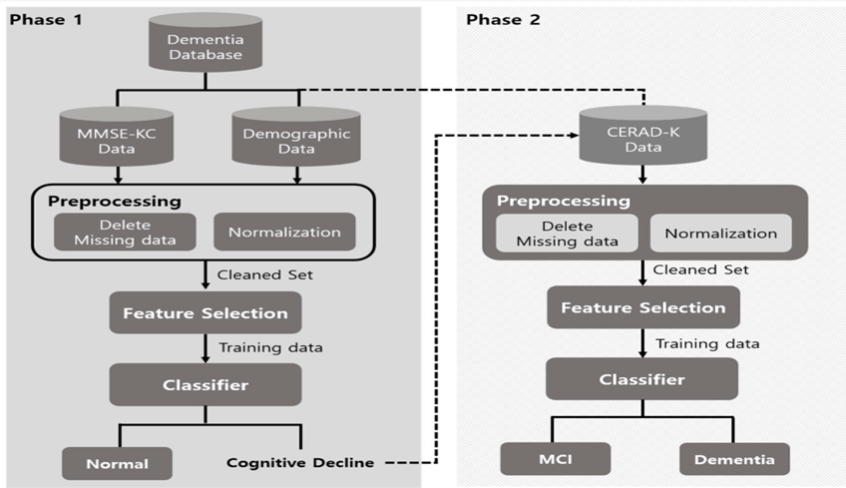**Figure:1**

Data Collection: The data used in the study were collected from people who visited the dementia center in Gangbuk-Gu, Seoul, from 2008 to 2013 and received a screening test. The data collection method is as follows. First, MMSE-KC examines the cognitive decline of the patient. If the resulting diagnosis indicates cognitive decline, CERAD-K would be further conducted.

**PHASE 1**

MLP has the highest accuracy for the diagnosis of dementia (Phase 1) and the value of this algorithm is equal to 97.2%. Additionally, the classification accuracy of random forest and bagging was 96.3% and 94.4%, respectively. According to Figure 2, Bayes Network and Naive Bayes have the lowest classification accuracy in the diagnosis of dementia. Moreover, the accuracy of SVM and logistic regression was almost equal, meaning that both algorithms possessed the classification accuracy of 91.7%.

**Figure:2**

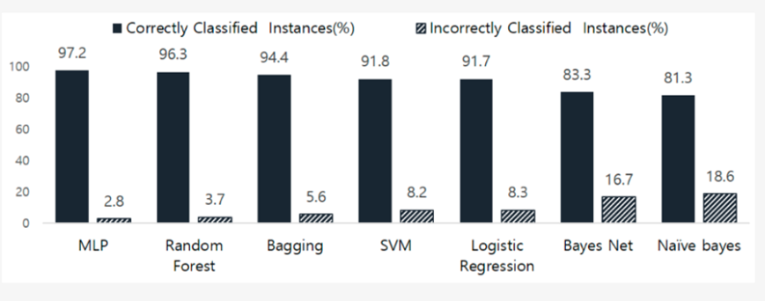

The Comparison of Data Classification Accuracy in Phase 1.

**PHASE 2**

**Figure:3**

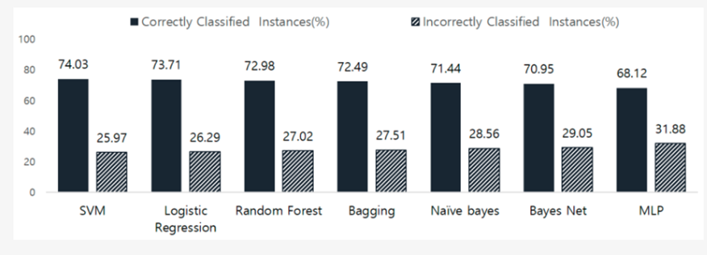

The Comparison of Data Classification Accuracy in Phase 2.

**Conclusion**

This study presents a two-layer model for early dementia diagnosis using MMSE-KC and CERAD-K data

 with machine learning techniques. It streamlines the diagnostic process, improving efficiency and accuracy. MLP and SVM yielded the best results in their respective phases. The model offers a fast, cost-effective, and reliable way to diagnose dementia at an early stage and suggests further research to enhance accuracy.

“**Performance of Machine Learning Algorithms for Predicting Progression to   Dementia in Memory Clinic Patients**”

[Charlotte James](https://pubmed.ncbi.nlm.nih.gov/?term=James+C&cauthor_id=34913981)[1](https://pubmed.ncbi.nlm.nih.gov/34913981/#affiliation-1)[2](https://pubmed.ncbi.nlm.nih.gov/34913981/#affiliation-2), [Janice M Ranson](https://pubmed.ncbi.nlm.nih.gov/?term=Ranson+JM&cauthor_id=34913981)[1](https://pubmed.ncbi.nlm.nih.gov/34913981/#affiliation-1)[2](https://pubmed.ncbi.nlm.nih.gov/34913981/#affiliation-2), [Richard Everson](https://pubmed.ncbi.nlm.nih.gov/?term=Everson+R&cauthor_id=34913981)[2](https://pubmed.ncbi.nlm.nih.gov/34913981/#affiliation-2)[3](https://pubmed.ncbi.nlm.nih.gov/34913981/#affiliation-3)[4](https://pubmed.ncbi.nlm.nih.gov/34913981/#affiliation-4), [David J Llewellyn](https://pubmed.ncbi.nlm.nih.gov/?term=Llewellyn+DJ&cauthor_id=34913981)[1](https://pubmed.ncbi.nlm.nih.gov/34913981/#affiliation-1)[2](https://pubmed.ncbi.nlm.nih.gov/34913981/#affiliation-2)[4](https://pubmed.ncbi.nlm.nih.gov/34913981/#affiliation-4)

1) University of Exeter Medical School, Exeter, United Kingdom.

2) Deep Dementia Phenotyping Network, United Kingdom.

3) Department of Computer Science, University of Exeter, Exeter, United Kingdom.

4) The Alan Turing Institute, London, United Kingdom.

This study addresses the challenge of identifying patients at risk of developing dementia within a clinically relevant 2-year timeframe in memory clinics. Current approaches, like focusing on those with mild cognitive impairment (MCI), have limitations, leading to misclassifications. Machine learning techniques are explored to predict dementia incidence based on memory clinic data from the US National Alzheimer Coordinating Center (NACC) without relying on advanced neuroimaging or genetic testing. Four ML algorithms—logistic regression, support vector machine, random forest, and gradient-boosted trees—were used for classification.

The study evaluates model performance through accuracy, sensitivity, specificity, and AUC. These models offer the potential to improve clinical decision-making and prioritize follow-up interventions, providing a valuable tool for identifying individuals at high risk of developing dementia within a 2-year time frame in memory clinic settings.

**Comparison With Existing Models**

The BDSI and CAIDE are existing dementia risk prediction models that assign to patients a score representing their risk of developing dementia over longer timescales.

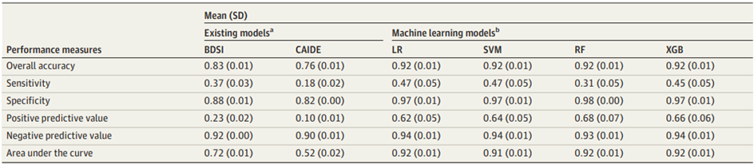

Performance Measures for the Prediction of Incident All-Cause Dementia Over 2 Years

This study explores the use of machine learning (ML) with memory clinic data from the US National Alzheimer Coordinating Center (NACC) to predict dementia incidence over a 2-year period. It aims to determine the minimal set of variables required for accurate prediction, avoiding the need for advanced neuroimaging or genetic testing. ML techniques offer promise for improving clinical decision-making in memory clinic settings.

**Model Performance across Dementia Subtypes**

The study evaluated machine learning model performance across different dementia subtypes, including Alzheimer's, LBD, vascular dementia, and other subtypes. The logistic regression model performed best for Alzheimer's and other subtypes, with correct classifications for 46% and 55% of cases, respectively. The support vector machine model excelled in identifying LBD cases, with a 49% accuracy, while all models correctly identified 33% of vascular dementia cases. Receiver operating characteristic curves showed similar performance across all subtypes.

The study also examined the minimum number of variables needed for optimal predictive power in machine learning models. They found that all models required only 22 variables to achieve diagnostic performance equivalent to using all 258 variables, without compromising diagnostic accuracy or practical implementation in clinical settings.

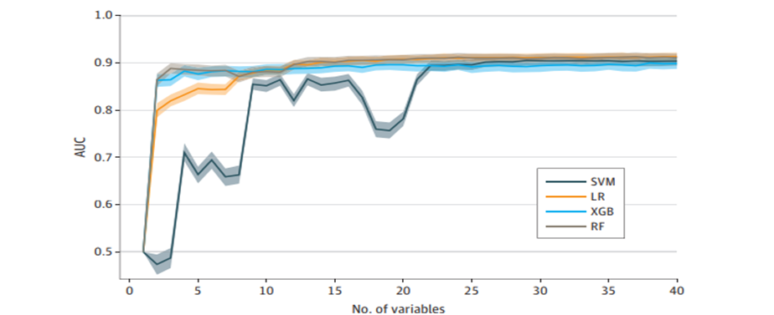

Unlike prior studies that focused on specific dementia types or conversions, this research offers a clinically relevant approach, covering all dementia types and initially cognitively unimpaired patients. Importantly, the ML models use only 6 key variables, making them highly practical for predicting all-cause dementia within a relevant timeframe.

**Limitations**

This study has limitations to consider. First, the models used were developed on different populations than the one in this study, which might have impacted their performance due to variations in available variables. Second, data imputation may introduce errors, especially when missing values are related to other variables. However, the study identified only 6 key variables with minimal missing data. Third, while the study included a large sample from US memory clinics, the generalizability of these findings to other populations remains uncertain.

**“Applications of artificial intelligence to aid early detection of dementia: A scoping review on current capabilities and future directions”**

**By** [Renjie Li](https://pubmed.ncbi.nlm.nih.gov/?term=Li+R&cauthor_id=35183766)[1](https://pubmed.ncbi.nlm.nih.gov/35183766/#affiliation-1), [Xinyi Wang](https://pubmed.ncbi.nlm.nih.gov/?term=Wang+X&cauthor_id=35183766)[2](https://pubmed.ncbi.nlm.nih.gov/35183766/#affiliation-2), [Katherine Lawler](https://pubmed.ncbi.nlm.nih.gov/?term=Lawler+K&cauthor_id=35183766)[3](https://pubmed.ncbi.nlm.nih.gov/35183766/#affiliation-3), [Saurabh Garg](https://pubmed.ncbi.nlm.nih.gov/?term=Garg+S&cauthor_id=35183766)[4](https://pubmed.ncbi.nlm.nih.gov/35183766/#affiliation-4), [Quan Bai](https://pubmed.ncbi.nlm.nih.gov/?term=Bai+Q&cauthor_id=35183766)[5](https://pubmed.ncbi.nlm.nih.gov/35183766/#affiliation-5), [Jane Alty](https://pubmed.ncbi.nlm.nih.gov/?term=Alty+J&cauthor_id=35183766)[6](https://pubmed.ncbi.nlm.nih.gov/35183766/#affiliation-6)

### Affiliations

1 School of Information and Communication Technology, University of Tasmania, TAS 7005, Australia. Electronic address: renjie.li@utas.edu.au.

2 Wicking Dementia Research and Education Centre, University of Tasmania, TAS 7000, Australia. Electronic address: xinyi.wang@utas.edu.au.

3 Wicking Dementia Research and Education Centre, University of Tasmania, TAS 7000, Australia; Royal Hobart Hospital, Tasmania, TAS 7000, Australia. Electronic address: katherine.lawler@utas.edu.au.

4 School of Information and Communication Technology, University of Tasmania, TAS 7005, Australia. Electronic address: saurabh.garg@utas.edu.au.

5 School of Information and Communication Technology, University of Tasmania, TAS 7005, Australia. Electronic address: quan.bai@utas.edu.au.

6 Wicking Dementia Research and Education Centre, University of Tasmania, TAS 7000, Australia; Royal Hobart Hospital, Tasmania, TAS 7000, Australia. Electronic address: [jane.alty@utas.edu.au](mailto:jane.alty@utas.edu.au).

In recent years, efforts have been made to develop advanced tests that directly detect dementia-related proteins through invasive methods like brain scans and spinal fluid tests. However, these remain costly and not widely accessible in clinical practice.

To address this challenge, a scoping review was conducted to explore the use of artificial intelligence (AI) in detecting dementia. The goal is to find cost-effective and accessible digital biomarkers to detect various types of dementia at a population level, offering promising directions for future research.

**Current Cognitive Tests**

Cognitive tests, [16], [17], [18], and [15], have been integral in dementia screening and diagnosis, providing "objective evidence" of cognitive impairment. However, they often rely on clinician interpretation, making them somewhat subjective. Most are score-based, and sensitivity/specificity for MCI and dementia are defined by set cut-offs.

In recent years, computerized cognitive tests have emerged as a promising alternative for dementia screening and detection, [19]. These tests not only gather total scores but also track participants' behavior during the assessments. They offer the advantage of user-directed testing, eliminating the need for direct administration by a clinician or researcher, [20]. This approach reduces costs, enhances accessibility, and minimizes inter-rater variability.

One notable example is CogState, [15], which is a user-friendly web-based battery that assesses various cognitive functions. These advancements aim to improve dementia detection and streamline the screening process.

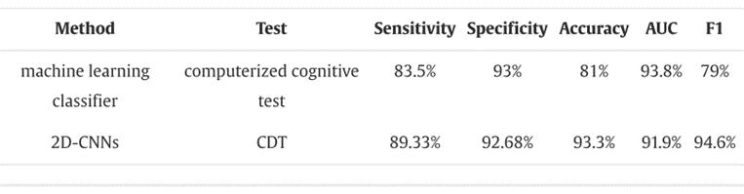

Performance of computerized cognitive screening tests to discriminate dementia from control

**Computer-assisted graphic drawings and handwriting tests**

Computer-assisted graphic drawing and handwriting tests offer alternative methods for assessing hand motor function. Yu et al. [21] conducted a study using these tests to differentiate motor function between AD, MCI, and healthy controls. They extracted movement fluency and handwriting accuracy features, finding that AD and MCI groups exhibited greater variation and errors in line drawing.

Impedovo et al. [22] integrated caregiver interviews, cognitive tests (MMSE), and computerized handwriting tasks. Handwriting features were analyzed, achieving an average precision of 0.72 for AD detection.

In smart environments, movement analysis has been employed for early detection of cognitive disorders. Paolini et al. [23] used RFID technology for indoor localization and inertial sensors for movement analysis.

Stavropoulos et al. [24] introduced a framework integrating various ambient sensors to monitor people with dementia, processing data for semantic interpretation and clinical use.

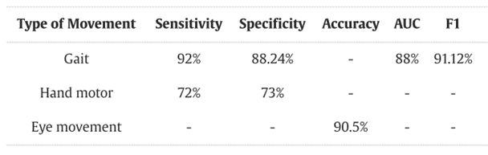

Performance of movement tests to discriminate dementia from controls.

**Conclusion**

This review explores the application of AI in developing digital biomarkers for early dementia detection. AI-based tests offer the potential to enhance the dementia detection process. They provide more features for analysis, improve accuracy by reducing subjective judgments, and automate screening, making them valuable for epidemiological studies and public health interventions. AI streamlines the process and responds efficiently to large-scale population screening, outperforming the reliance on clinicians alone.

**Limitations**

The extent of this scoping review is limited to a focus on published papers that provide results and thus papers that proposed ideas without any results have not been included. This may have excluded some good protocols, expert opinions and other studies that have not been peer reviewed. The second limitation is that when comparing the performances, they have ignored the impact of different experiment designs. For example, some experiments may have included fewer participants, or older participants in one group compared to the other, which tend to bias the results.

**“ Diagnosis of Alzheimer's Disease using Machine Learning”**

**By** Priyanka Lodha,Ajay Talele ,Kishori Degaonkar

Department of EnTC Vishwakarma Institute of Technology, Pune India

The research paper underscores the critical role of early detection in managing Alzheimer's disease. As there is currently no proven cure for AD, timely intervention is essential to provide individuals with the appropriate care and support. The authors highlight the importance of more efficient solutions for detecting AD in its early stages.

**Machine Learning and Alzheimer's Disease Diagnosis:**

The paper delves into the potential of machine learning algorithms to process data obtained from neuroimaging technologies, such as MRI scans. These algorithms aim to predict the presence of AD by extracting valuable insights from cognitive and medical factors, including RAVLT tests, MOCA scores, and FDG measurements.

**Data Analysis:**

The authors employ data analysis techniques, including scatter plots and graphs, to illustrate correlations between different variables. For example, they use scatter plots to demonstrate the relationship between whole brain volume, hippocampus volume, and MOCA scores, indicating that these factors can be indicative of AD.

**Machine Learning Algorithms:**

The research discusses the implementation of various machine learning algorithms, including Support Vector Machine (SVM), Gradient Boosting, Neural Network, K-Nearest Neighbor (KNN), and Random Forest. These algorithms are leveraged to predict AD using data from the Alzheimer's Disease Neuroimaging Initiative (ADNI).

**Accuracy and Performance:**

The paper presents an accuracy table that showcases the performance of different machine learning models. The results suggest that the Neural Network and Random Forest algorithms achieve the highest accuracy in predicting AD. The study highlights the potential of these models for early diagnosis.

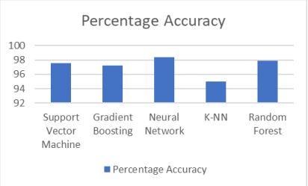

**Limitations:**

While the research paper offers valuable insights into the potential of machine learning for AD diagnosis, it is essential to consider its limitations:

1. Data Quality: The accuracy of machine learning models is highly dependent on the quality and quantity of data. The paper does not extensively discuss data quality issues or potential biases in the ADNI dataset.

2.Generalizability: The study primarily relies on data from the ADNI dataset, which may not fully represent the diversity of AD patients. The generalizability of the models to different populations and demographics remains uncertain.

3.Clinical Validation: The paper focuses on the predictive performance of machine learning models but lacks clinical validation. Further research is needed to validate the practical utility of these models in real-world clinical settings.

4.Interpretability: Machine learning models are often criticized for their lack of interpretability. The paper does not delve into the interpretability of the models, which is crucial for gaining insights into the disease's progression.

**Conclusion:**

The research paper emphasizes the significance of early detection of AD and the potential of machine learning in achieving this objective. While showing promise in predictive accuracy, the study also highlights certain limitations that should be addressed in future research. By acknowledging these limitations, researchers can develop more robust and clinically applicable models for the early diagnosis and treatment of Alzheimer's disease.

**“Machine Learning for Dementia Prediction: A Systematic Review and Future Research Directions”**

Ashir Javeed1,2 · Ana Luiza Dallora2  · Johan Sanmartin Berglund2  · Arif Ali3  · Liaqat Ali4  · Peter Anderberg2,5

This paper highlights the importance of a systematic literature review (SLR) in the context of automated diagnostic systems for dementia prediction. Unlike previous SLRs that had limited scope and overlooked methodological limitations, this SLR focuses on deep learning and machine learning algorithms. Its goal is to evaluate these algorithms' performance in predicting various dementia subtypes using diverse data modalities. The paper aims to provide a comprehensive analysis of the current state of automated dementia prediction and identify areas for future research and improvement.

**Article Selection**

In this SLR study, articles were selected based on keywords like ML, DL, dementia, and its subtypes (AD, VaD, FTD, MD). A total of 450 research studies were gathered from various online databases. After reviewing titles and abstracts, 330 articles were considered for further processing. Following deduplication and screening, 125 full-text publications were retrieved. Out of these, 75 research papers met the eligibility criteria. These articles covered various data modalities (image, clinical-variables, voice) with 25 papers each. No additional suitable articles were found in a subsequent search in May 2022.

The selection criteria included studies that presented automated diagnostic systems for dementia and its subtypes (AD, VaD, FTD, MD), published between 2011 and 2022, utilizing ML approaches for dementia diagnosis, employing multiple data modalities, and being published in the English language.

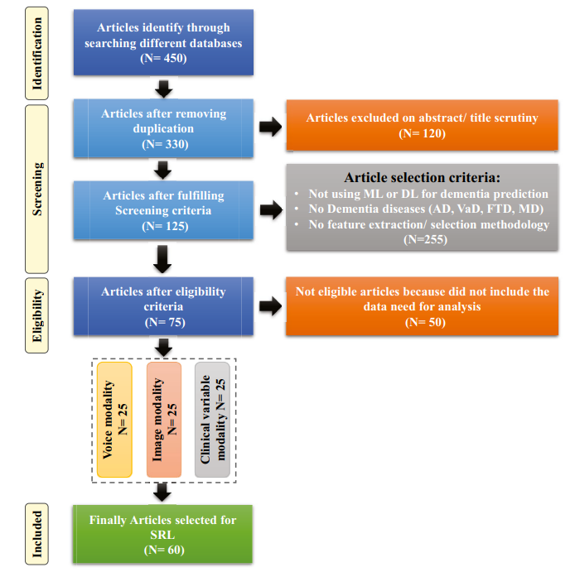

Flow diagram of PRISMA (Preferred Reporting Items for Systematic Reviews and Meta-analyses)

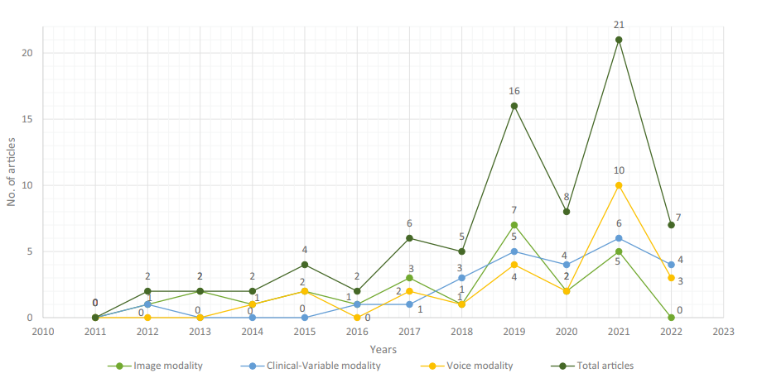

Selected research articles which are published from 2011 to 2022 regarding data modality

**Datasets**

In the section discussing datasets, the selected research papers used various datasets to experiment and evaluate the performance of automated diagnostic systems for dementia and its subtypes employing ML algorithms. A total of 61 datasets were considered from these research articles, originating from diverse organizations and hospitals worldwide. Some datasets were publicly available, while others were curated by researchers from healthcare institutions.The categorization of these datasets was based on data modality, resulting in three main types: images, clinical variables, and voice datasets. These datasets varied in terms of the number of features and samples they contained. As a result, the researchers systematically examined each type of dataset individually. They utilized a range of ML and DL techniques to work with these datasets, enabling comprehensive analysis and comparison across different data modalities to enhance the understanding of automated diagnostic systems for dementia and its subtypes.

**Image Based**

**1.Dataset**

Researchers used various image datasets, particularly MRI-based datasets, for diagnosing dementia. The Open Access Series of Imaging Studies (OASIS) and Alzheimer's Disease Neuroimaging Initiative (ADNI) datasets were frequently employed for experiments. OASIS offers neuroimaging data to the scientific community, whereas ADNI collects data like MRI, PET imaging, genetics, cognitive assessments, and biomarkers for disease prediction. These datasets contain diverse samples and variables. Table 1 in the paper lists dataset information, including dataset name, sample count, variables, and dementia type.

**2. ML Based Diagnostic Model**

Researchers have developed several ML and DL algorithms for dementia detection using MRI brain images. For instance, Dashtipour achieved a 91.28% accuracy for Alzheimer's disease prediction using DL and SVM. Helaly used CNNs to detect AD stages with promising accuracies. Different methods, including SVM, LASSO, and fine-tuned networks, demonstrated success in various studies, achieving high accuracy in dementia prediction. These approaches showcase the potential of AI in early diagnosis and classification of dementia.

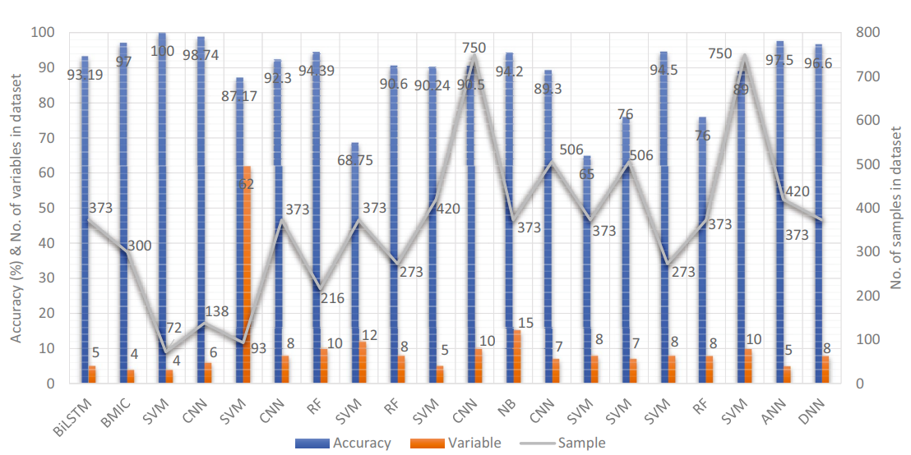

Accuracy comparison of different ML models based on image modality

**Clinical-variable based**

**1.  Dataset**

The increasing use of medical devices and the availability of electronic health records (EHR) have led to a vast collection of clinical data. This clinical data, which includes medical tests and patient records, plays a crucial role in disease prediction and proactive management. Datasets based on clinical variables for dementia contain information from medical tests like MMSE, MoCA, TICS, and BIMS, along with patient details like age, sex, and marital status. Table 2 in the paper outlines clinical-variable datasets used by researchers in developing automated diagnostic systems for dementia, providing details on dataset specifics, sample size, variables, and dementia type.

**2. ML Based Diagnostic Model**

Numerous research studies have employed ML techniques with clinical-variable data for dementia prediction. For example, Chiu designed a questionnaire for MCI and dementia screening with a 94.00% AUC. Stamate's framework achieved 88.00% accuracy for dementia detection. They also developed a system for detecting dementia subtypes, reporting AUC values around 85%. Bansal compared different ML models and found J48 to outperform others.

Salem presented a regression-based ML model for dementia prediction, achieving high performance with balanced RF and calibrated-weighted SVM. Gutierrez designed an automated diagnosis system with an 84% accuracy. Hsiu's model reached 70.32% accuracy for early cognitive impairment identification. Shahzad's MCI pre-screening model based on gait biomarkers achieved 71.67% accuracy.

Hane used clinical notes to enhance ML models, improving the AUC from 85.00% to 94.00%. Table 5 in the paper provides a comprehensive overview of the ML model performance in predicting dementia and its subtypes using clinical-variable data.

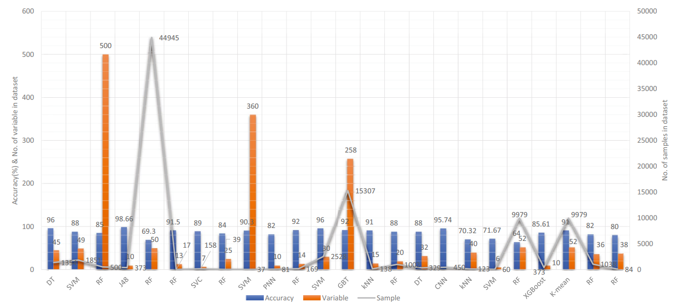

Accuracy comparison of different ML models based on clinical-variable modality

**Voice Based**

**1. Dataset**

Speech analysis is a valuable tool for detecting neurodegenerative disorders affecting language processing. Individuals with conditions like Parkinson's disease (PD), Alzheimer's disease (AD), and Primary Progressive Aphasia (PPA-NF) may have speech difficulties. Researchers used voice recording data alongside ML and DL algorithms to identify dementia. Data collection methods varied across datasets, including prepared questions and neuropsychological tests. Table 3 in the paper provides details on voice-based datasets for dementia identification.

**2. ML Based Diagnostic Model**

Researchers have developed automated diagnostic systems for predicting dementia using voice data. Notable studies include Chlasta and Wolk's work, which used DL and ML techniques to screen dementia patients through speech analysis, and Chien et al.'s ML model that assessed Alzheimer's disease using speech data with an accuracy of 83.80%. Shimoda et al. identified dementia risk through voice features in telephone conversations using ML models like XGBoost, RF, and LR. Other studies by Liu, Searle, and Zhu employed various ML techniques to recognize Alzheimer's disease and achieved accuracies ranging from 82.00% to 84.40%. These studies indicate the potential of voice-based data in dementia diagnosis.

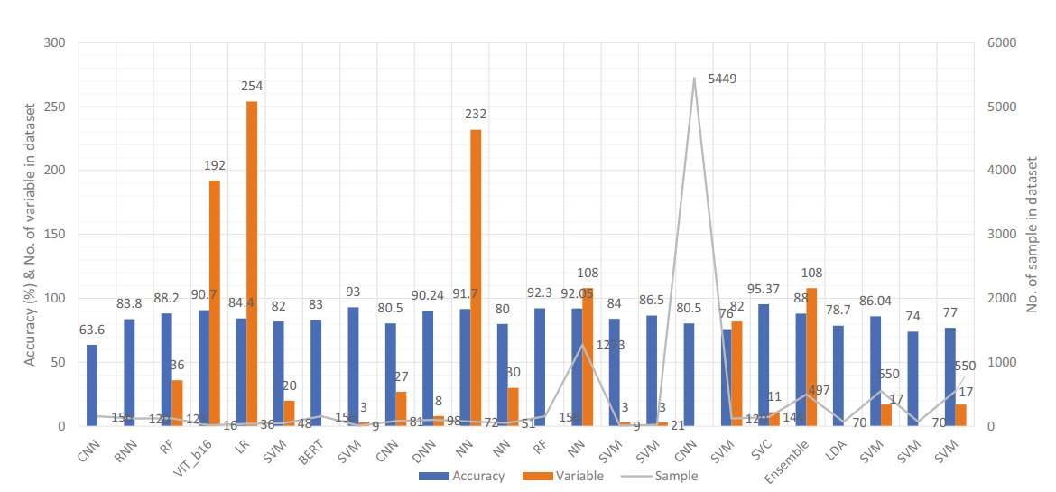

Accuracy comparison of different ML models based on voice modality

**Model Comparison**

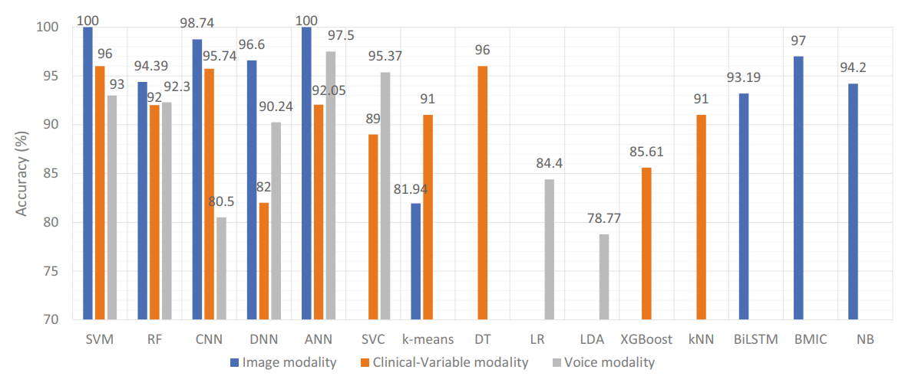

Accuracy comparison of ML models based on data modality

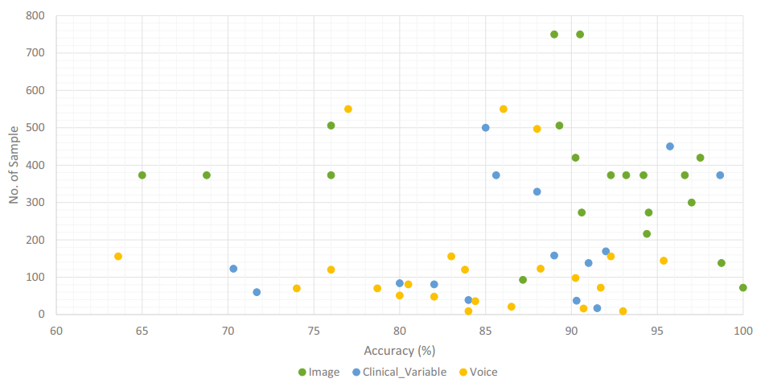

Accuracy comparison of ML models along with number of sample in the dataset based on data modality

**Addressing Limitations in the previously proposed ML models**

This part of the paper plays a crucial role in distinguishing itself from previous research, as it addresses limitations that have often been overlooked or inadequately handled in many existing papers. Here's a more detailed explanation of how this part differs from common practices:

**Overlooked Overfitting:** While many papers may mention the problem of overfitting, they often fail to provide a concrete solution or sufficient evidence of addressing it. In contrast, this paper promotes standardized data partitioning techniques like k-fold cross-validation as a practical solution to mitigate overfitting. By emphasizing this, the paper goes beyond mere recognition and actively promotes best practices.

**Imbalanced Class Neglect:** Previous papers may acknowledge the issue of imbalanced class distributions in datasets but frequently lack a clear strategy to rectify it. This paper not only highlights the importance of addressing class imbalances but also recommends specific techniques like random oversampling and SMOTE to effectively handle this challenge. This proactive approach sets it apart from papers that merely acknowledge the issue.

**Consistency in Evaluation:** Commonly, papers lack consistency in the evaluation of ML models, using different data partitioning methods without justification. In contrast, this paper emphasizes the need for standardized data partitioning schemes, such as holdout and cross-validation, to ensure a fair and consistent basis for evaluating dementia prediction models.

**Time Complexity Recognition:** While other papers may mention the time complexity of training and tuning ML models, this paper brings attention to the substantial effort and time required for hyperparameter tuning and model training. Although it doesn't offer a direct solution, the paper's focus on this aspect indicates an awareness of potential time-related challenges.

**Economical DL Usage:** Deep learning methods are known for their need for massive datasets and powerful hardware. This paper recognizes this concern.

Title

**Research Gap**

Throughout all these papers we viewed for our literature survey the general methodologies have been using clinical data to aid in prediction of dementia or comparing various models on a particular dataset or comparing the various data modalities and see which gives the best possible results.

While these approaches have contributed significantly to our understanding of dementia, there exists an unaddressed critical concern that warrants attention: the issue of timing and the financial burden borne by patients.

One of the often-overlooked aspects is the timing of diagnosis. By the time patients, their friends, or family members perceive cognitive decline, it may unfortunately be too late. Dementia, in its early stages, can be insidious, and significant neurological damage may have already occurred. Diagnosis often occurs years after the onset of cognitive decline when individuals seek clinical evaluation. Early detection is paramount for implementing preventive measures and interventions that can slow the progression of the disease.

Moreover, there is a notable scarcity of research attention given to the economic implications of dementia care. Most of these studies have been conducted in affluent nations where healthcare resources are relatively abundant. However, as nations like India, China, and other Southeast Asian countries anticipate a surge in dementia cases, it is imperative to address the cost factors associated with diagnosis, treatment, and caregiving. Lower-income countries must seek cost-effective strategies to provide quality care and support for individuals with dementia. Research should encompass a holistic approach that not only enhances predictive accuracy but also prioritizes early detection and minimization of the financial burden on patients and their families. This multifaceted perspective is essential for the global response to the growing dementia epidemic.

# Chapter 2

# Problem Statement

The biggest motivation of doing this paper is Now a days X-ray and CT in medicine use high-resolution images, they require high specification equipment and huge energy consumption due to high computation in learning and recognition, incurring huge costs to create an environment for operation. Thus, this paper proposes a chest X-ray outlier detection model which will decrease the working time.

**2.1. Research Objectives**

**2.2. Methodology of the Work**

# Chapter 3

# Analysis and Design

There’s a lot research based on chest X-Ray detection for COVID-19 detection -

* Deep Convolutional Approaches for the Analysis of COVID-19 Using Chest X-Ray Images From Portable Devices
* Deep Learning Approaches for Detecting COVID-19 From Chest X-Ray Images: A Survey by Hanan S.alghamdi

# Chapter 4

# Results and Discussion

* Our Research proposes a chest X-ray outlier detection model using dimension reduction and edge detection. Unlike the existing dimension reduction techniques, the proposed algorithm uses its own data as the standard for dimension reduction and always applies a consistent classification criterion.
  + In the existing techniques, classification criteria changed according to the number of learning data, class distribution, and type. However, this may degrade the performance of recognition by reanalyzing the classification criteria and using inefficient classification when applied to additional learning data and daily life data.
  + Moreover, it realizes the prediction of response to different treatment modalities because it can predict the pattern of cardiovascular complications.
  + Hence, considering their properties and multiple advantages, ELMs are recom- mended for such problems.
  + However, it should be noted while AI speeds up the methods to conquer COVID-19,

real experiments should happen because a full understanding of advantages and limita- tions of AI-based methods for COVID-19 is yet to be achieved, and novel approaches have to be in place for problems of this level of complexity.

* + The RNN, as alternatively called Auto Associative or Feedback Network, falls in the

category of LSTM in which a directed cycle is made through connections between units. Being a widely appreciated DL family, RNNs have succeeded to present promising results in a lot of machine learning and computer vision tasks. One important task to use this model, however, is the quantification of qualitative inputs such as country and location.

TitleSS

Updating the model is possible because of the real-time data by LSTM with real-time learning capability. Utilization of the proposed LSTM model provides the opportunity of proposing the epidemiological model of the virus in different locations. The main objective of the proposed structure is to improve the accuracy and speed of recognition and classification of the issues caused by the virus by utilizing DL-based methods.

# Conclusion and Future Scope

In conclusion, our research addresses the critical concerns surrounding dementia diagnosis, focusing on the often-overlooked aspects of timing and financial burden borne by patients and their families. We have highlighted the urgency of early detection, emphasizing its paramount importance in implementing preventive measures and interventions to slow down the progression of the disease. Recognizing the insidious nature of dementia, our proposed three-step method aims to minimize the cost burden on patients by filtering out those at low risk, thereby optimizing the utilization of healthcare resources.

For Future scope, we have considered the following factors into consideration:

**Advancing Diagnostics with MRI Integration**

One of our key focuses is integrating advanced medical imaging techniques, particularly MRI, into our research methodology. This integration aims to provide a detailed understanding of dementia by analyzing intricate brain imagery, thereby enhancing the precision and depth of our diagnostic capabilities.

**Enabling Personalized Interventions through Wearable Devices**

Our research is exploring real-time monitoring using wearable devices and IoT sensors. These cutting-edge technologies capture subtle changes in patient behavior and vital signs, offering continuous, dynamic data. This approach empowers personalized interventions, ensuring timely responses tailored to individual patient needs.

**Elevating Accuracy with Enhanced Machine Learning Algorithms**

Future efforts are directed towards refining existing machine learning algorithms. Through exploration of novel methodologies, we aim to elevate the predictive accuracy of dementia detection. These advancements are pivotal, enabling early identification and intervention, ultimately improving patient outcomes and treatment efficacy.

**Building Trust via Transparent AI Decision-Making**

Transparency is central to our approach. We are integrating explainable AI techniques to ensure the decision-making process is accessible and understandable for healthcare professionals and caregivers. This transparency fosters trust, allowing stakeholders to confidently rely on AI-driven diagnostic insights.

**Collaborative Data Insights for Comprehensive Understanding**

Our research journey involves collaboration with healthcare providers, research institutions, and data scientists. These partnerships enable us to curate diverse and representative datasets, enhancing the depth and applicability of our findings across diverse demographic and cultural contexts. Through collaborative data insights, we strive for a comprehensive understanding of dementia.

# References

**[1]** [So A, Hooshyar D, Park KW, Lim HS. Early Diagnosis of Dementia from Clinical Data by Machine Learning Techniques. *Applied Sciences*. 2017; 7(7):651. <https://doi.org/10.3390/app7070651>]

**[2]** [James C, Ranson JM, Everson R, Llewellyn DJ. Performance of Machine Learning Algorithms for Predicting Progression to Dementia in Memory Clinic Patients. *JAMA Network Open*. 2021;4(12):e2136553. Published 2021 Dec 1. doi:10.1001/jamanetworkopen.2021.36553]

**[3]** Li, R., Wang, X., Lawler, K., Garg, S., Bai, Q., & Alty, J. (2022). Applications of artificial intelligence to aid early detection of dementia: A scoping review on current capabilities and future directions. *Journal of biomedical informatics*, *127*, 104030. <https://doi.org/10.1016/j.jbi.2022.104030>

**[4]** . Mitchell AJ, Shiri-Feshki M. Rate of progression of mild cognitive impairment to dementia—meta-analysis of 41 robust inception cohort studies. Acta Psychiatr Scand. 2009;119(4):252-265. doi:10.1111/j.1600-0447.2008. 01326.x

**[5]** . Hastie T, Tibshirani R, Friedman J. The Elements of Statistical Learning: Data Mining, Inference, and Prediction. Springer Science & Business Media; 2009. doi:10.1007/978-0-387-84858-7

**[6]** Hosmer Jr DW, Lemeshow S, Sturdivant RX. Applied Logistic Regression. John Wiley & Sons; 2013. doi:10. 1002/9781118548387

**[7]** Cortes C, Vapnik V. Support-vector networks. Mach Learn. 1995;20(3):273-97. doi:10.1007/BF00994018

**[8]** Breiman L. Random forests. Mach Learn. 2001;45(1):5-32. doi:10.1023/A:1010933404324

**[9]** . Ho TK. Random decision forests. In: Proceedings of the 3rd International Conference on Document Analysis and Recognition. IEEE; 1995:278-282.

**[10]** . Friedman JH. Stochastic gradient boosting. Computational Stat Data Analysis. 2002; 38(4):367-78. doi:10.1016/ S0167-9473(01)00065-2

**[11]** Pedregosa F, Varoquaux G, Gramfort A, et al, Scikit-learn: machine learning in Python.J Mach Learn Res. 2011; 12:2825-2830.

**[12].** Cui Y, Liu B, Luo S, et al; Alzheimer’s Disease Neuroimaging Initiative. Identification of conversion from mild cognitive impairment to Alzheimer’s disease using multivariate predictors. PLoS One. 2011;6(7):e21896. doi:10. 1371/journal.pone.0021896

**[13]**  Zhan Y, Chen K, Wu X, et al; Alzheimer’s Disease Neuroimaging Initiative. Identification of conversion from normal elderly cognition to Alzheimer’s disease using multimodal support vector machine.J Alzheimers Dis. 2015; 47(4):1057-1067. doi:10.3233/JAD-142820

**[14]** Bruscoli M, Lovestone S. Is MCI really just early dementia: a systematic review of conversion studies. Int Psychogeriatr. 2004;16(2):129-140. doi:10.1017/S1041610204000092

**[15]** Kelvin K.F. Tsoi, Joyce Y.C. Chan, Hoyee W. Hirai, Samuel Y.S. Wong, Timothy C.Y. Kwok Cognitive tests to detect dementia: a systematic review and meta-analysis JAMA Internal Med., 175 (9) (2015), pp. 1450-1458

**[16]** G. Irving, R.A. Robinson, W. McAdam The validity of some cognitive tests in the diagnosis of dementia Brit. J. Psychiatry, 117 (537) (1970), pp. 149-156

**[17]** Wendy J. Lorentz, James M. Scanlan, Soo Borson Brief screening tests for dementia Canad. J. Psychiatry, 47 (8) (2002), pp. 723-733

**[18]** T. Cukierman, H.C. Gerstein, J.D. Williamson Cognitive decline and dementia in diabetes–systematic overview of prospective observational studies Diabetologia, 48 (12) (2005), pp. 2460-2469

**[19]** Latha Velayudhan, Seung-Ho Ryu, Malgorzata Raczek, Michael Philpot, James Lindesay, Matthew Critchfield, Gill Livingston Review of brief cognitive tests for patients with suspected dementia Int. Psychogeriat., 26 (8) (2014), pp. 1247-1262

**[20]** Ziad S. Nasreddine, Natalie A. Phillips, Valérie Bédirian, Simon Charbonneau, Victor Whitehead, Isabelle Collin, Jeffrey L. Cummings, Howard Chertkow The montreal cognitive assessment, moca: a brief screening tool for mild cognitive impairment J. Am. Geriatr. Soc., 53 (4) (2005), pp. 695-699

**[21]** Yu. Nan-Ying, Shao-Hsia Chang Characterization of the fine motor problems in patients with cognitive dysfunction–a computerized handwriting analysis Human Movement Sci., 65 (2019), pp. 71-79

**[22]** Donato Impedovo, Giuseppe Pirlo, Gennaro Vessio, Maria Teresa Angelillo A handwriting-based protocol for assessing neurodegenerative dementia Cognit. Comput., 11 (4) (2019), pp. 576-586

**[23]** Giacomo Paolini, Diego Masotti, Alessandra Costanzo, Elena Borelli, Lorenzo Chiari, Silvia Imbesi, Michele Marchi, Giuseppe Mincolelli, Human-centered design of a smart “wireless sensor network environment enhanced with movement analysis system and indoor positioning qualifications, in: 2017 IEEE MTT-S International Microwave Workshop Series on Advanced Materials and Processes for RF and THz Applications (IMWS-AMP), pages 1–3. IEEE, 2017.

**[24]** Thanos G. Stavropoulos, Georgios Meditskos, Stelios Andreadis, Konstantinos Avgerinakis, Katerina Adam, Ioannis Kompatsiaris Semantic event fusion of computer vision and ambient sensor data for activity recognition to support dementia care J. Ambient Intell. Humanized Comput. (2016), pp. 1-16

**[25]** Chiara Longoni, Andrea Bonezzi, Carey K Morewedge, Resistance to Medical Artificial Intelligence, Journal of Consumer Research, Volume 46, Issue 4, December 2019, Pages 629–650, <https://doi.org/10.1093/jcr/ucz013>

**Instructions**

1. All the pages should be numbered at the bottom right side of the page.
2. The formatting of dissertation/report should be in APA format.
3. All the References should be mentioned in the APA format.
4. All the tables and figures should be labeled. The compiled list of the tables and figures should be presented in the appendix.
5. The report should be original in its work. Only 20% of plagiarism is permissible. Students must attach an Undertaking for plagiarism report at the designated place of the report.
6. The students must get the report verified, evaluated and signed by the supervisor before its final submission in the spiral bound form and incorporate any changes, suggestions or recommendations as directed by the supervisor.
7. The students should bring the final report (spiral bound) on the day of End-Semester Project Presentation and submit it to their respective panelists.
8. The format of BTP/MTP report shared should be strictly followed.
9. The Problem Statement and Objectives submitted during the Mid-Term Presentation must be attached to the Final report after the Bonafide certificate given in the sample report.
10. The **order of report** should be in the following format:
11. Title Page
12. Bonafide Certificate, Conflict of Interest and Undertaking for Plagiarism
13. Problem statement and objectives submitted during the Mid-Term Presentation (**Internship** students should skip this section)
14. Abstract with keywords
15. Contents
16. Chapters as suggested in report

11. All the data/tables/figures taken from other sources should be duly credited in the footnotes or references.

12. The font size should be 12 throughout the document. The title should be Font size 17 and sub-heading should be Font Size 14, followed by under subheadings as Font Size 12. The Font Style must be **Times New Roman Only** and spacing between each line must be 1 and between headings should be 2.

13. The spacing between each line must be 1.15 and between headings must be 2.

14. All the paragraphs must be aligned as “justify” while the headings must be in center, the sub-headings should be left aligned.